**PASSPORT**

**Nizhny Novgorod region**

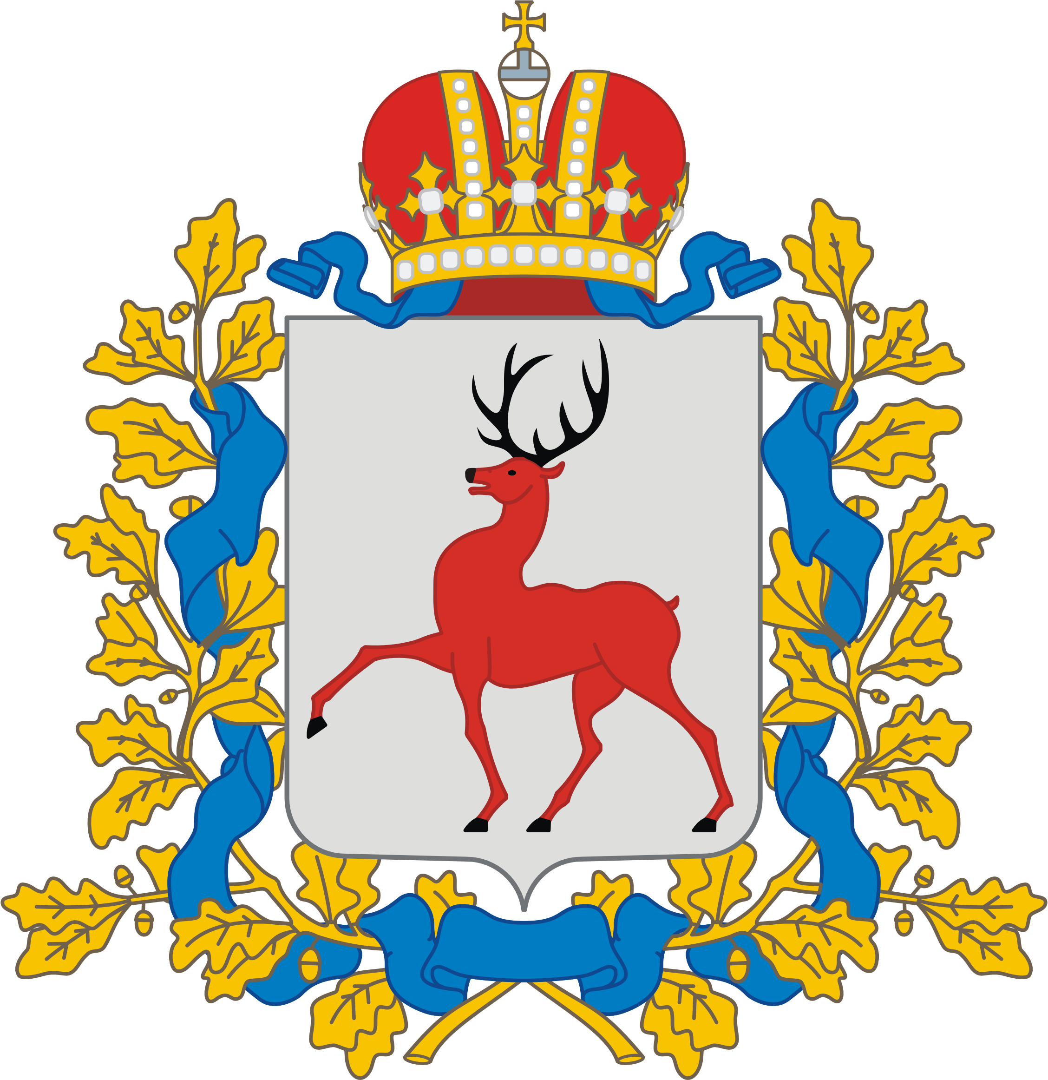**The Nizhny Novgorod Region** occupies a favorable geographical position in the central European part of Russia (East European Plain), 400 km east of Moscow, at the confluence of two major rivers - the Volga and the Oka.

**Total area** – 76.6 thousand square kilometers.

**Population –** 3.06 million.

**Governor of the Nizhny Novgorod Region –** Gleb Nikitin.

In the northwest the region borders with Kostroma Region, in the northeast – with Kirov Region, in the east – with Mari El and Chuvashia, in the south – with Mordovia, in the southwest – with Ryazan Region, in the west – with Vladimir and Ivanovo Regions.

**Ecology and nature protection**

The Nizhny Novgorod Region is one of the largest forest regions in the European part of the Russian Federation; more than 50% of the territory is covered by forests.

Since 1993, the Kerzhensky State Nature Biosphere Reserve (area - 47 thousand hectares) has been operating in the Nizhny Novgorod Region. It was created with the aim of preserving and restoring biological diversity and the integrity of indigenous types of natural communities.

The region's territory includes 15 state reserves of regional significance with an area of over 270 thousand hectares, 1 natural monument of federal significance and   
384 natural monuments of regional significance.

**Population**

The population (as of January 1, 2024) is 3.06 million, population density:   
39.94 people per 1 sq. km, the proportion of urban population: 81.21%.

The population (according to the 2010 census) is represented by the following nationalities: Russians (95.1%), Tatars (1.4%), Mordvins (0.6%), Ukrainians (0.5%), other nationalities (2.4%).

The administrative center of the region is Nizhny Novgorod with a population of   
1 million 250 thousand 300 people (according to information as of January 1, 2024).

The largest cities in the region: Dzerzhinsk (215.3 thousand people), Arzamas (103.6 thousand people), Sarov (94.1 thousand people), Bor (77.3 thousand people), Kstovo (61.6 thousand people), Pavlovo (55.9 thousand people), Balakhna (47.4 thousand people), Vyksa (44.1 thousand people).

**Administrative-territorial structure**

The Nizhny Novgorod Region is part of the Volga Federal District and includes   
51 municipalities, including 6 urban districts and 45 municipal districts.

**Socio-economic situation, nature and potential of the economy, the place of the region in the economic life of Russia**

The subsistence minimum per capita at the end of 2024 was 14.3 thousand rubles. The registered unemployment rate at the end of 2024 was 0.04%.

The Nizhny Novgorod Region is a powerful industrial center, the dynamic development of which is due, first of all, to the presence of science-intensive high-tech industries.

Industry is the basis of the economy of the Nizhny Novgorod Region: it accounts for more than a third of the gross regional product of the region.

There are approximately 600 large and medium-sized industrial enterprises operating in the region’s industry, as well as about 50 industry research institutes and design bureaus.

The production index for the full range of enterprises for 2024 amounted to 103.9%, while in manufacturing industries it was 103.8%.

The main priority areas for the development of the region's exports in the commodity structure are: mechanical engineering, petroleum products and chemical products, products made of ferrous metals, plastics, ground transport vehicles, wood and pulp and paper products, fats and oils of animal and vegetable origin.

The main promising export destinations are the CIS, SCO and BRICS countries, as well as individual countries in Asia, Africa, Latin America and Europe.

The specialized organization for supporting export and import activities in the Nizhny Novgorod Region is the autonomous non-profit organization «Corporation for the Development of Industry and Entrepreneurship of the Nizhny Novgorod Region» (https://krpp-no.ru/), headed by Ivan Razuvaev.

Address: 603144, Nizhny Novgorod, Academician Sakharov St., 4, office 516, Ankudinovka Technopark building, tel.: +7 (831) 435-17-00.

**International relations, existence of agreements with foreign partners**

In 2024, 218 foreign delegations from 90 countries visited the Nizhny Novgorod Region through executive authorities and local governments. Including visits by 42 heads of government bodies, 21 heads of diplomatic missions of foreign states in the Russian Federation.

Representatives of near and far abroad countries such as Abkhazia, Australia, Azerbaijan, Argentina, Armenia, Bangladesh, Bahrain, Belarus, Bosnia and Herzegovina, Brazil, Burkina Faso, Burundi, Venezuela, Hungary, Vietnam, Haiti, Gambia, Guatemala, Guinea, Germany, Honduras, Greece, Georgia, Democratic Republic of the Congo, Egypt, Zimbabwe, Israel, India, Indonesia, Jordan, Iran, Spain, Italy, Yemen, Kazakhstan, Cambodia, Canada, Cameroon, Kyrgyzstan, China, Costa Rica, Cuba, Laos, Liberia, Mauritania, Madagascar, Malawi, Malaysia, Morocco, Mexico, Mozambique, Moldova, Mongolia, Myanmar, Namibia, Niger, Nicaragua, UAE, Oman, Pakistan, Papua New Guinea, Peru, Poland, Portugal, Republic of the Congo, Republic of Korea, Saudi Arabia, Senegal, Saint Vincent and the Grenadines, Saint Lucia, Serbia, USA, Thailand, Tajikistan, Turkmenistan, Turkey, Uganda, Uzbekistan, Philippines, France, Montenegro, Czech Republic, Switzerland, Sri Lanka, Ecuador, Ethiopia, South Africa, South Ossetia.

In 2024, the Nizhny Novgorod Region became one of the centers for holding events under the Russian BRICS Presidency Plan.

The following events took place in the Nizhny Novgorod Region:

- International scientific and practical forum on the topic: «Current issues of combating money laundering and terrorist financing» (April 24-26);

- BRICS Sherpa/Sous-Sherpa meeting and BRICS Foreign Ministers meeting, as well as an extended session with the participation of Foreign Ministers of the Global South and East (June 7-11);

- 10th BRICS Environment Ministers Meeting (June 26-28);

- BRICS Sister Cities and Local Governments Forum (July 9-10);

- 8th BRICS Industry Ministers Meeting (August 15-17);

- 8th meeting of the BRICS Working Group on Information and Communication Technologies and High Performance Computing Systems (September 20).

In 2024, the signing of 10 contractual documents with foreign partners was also organized through the Government and local governments of the Nizhny Novgorod Region (with regions and municipalities of such countries as Belarus, Abkhazia, Republika Srpska, China and Uzbekistan).

In the region there is a branch of the Embassy of the Republic of Belarus in the Russian Federation in Nizhny Novgorod, 6 offices of honorary consuls: Abkhazia, Austria, Armenia, Bosnia and Herzegovina, Malta, Kyrgyzstan; 7 foreign centers: Hungary, China, Serbia, Thailand, France, Czech Republic, Japan.

**Science and Education**

As of 2024, 11 universities, more than 100 research organizations and 3 institutes of the Russian Academy of Sciences have a valid license in the Nizhny Novgorod Region.

In total, about 100 thousand students are studying in higher educational institutions of the Nizhny Novgorod Region in the 2024-2025 academic year, of which more than 7 thousand are foreign students (an increase of 20% compared to the 2023-2024 academic year) from 105 countries of the near and far abroad. The largest number of students came from Uzbekistan, Turkmenistan, Egypt, China, India, Iraq, Algeria, Kazakhstan, Kyrgyzstan and Syria.

**Culture, local traditions**

The Nizhny Novgorod Region has always been famous for its crafts (more than 60% of crafts are concentrated in the region), ranking first in Russia in the number of preserved folk art crafts. This is a unique experience on a national scale.

The Nizhny Novgorod Region is the birthplace of the famous Gorodets wood painting. Among the most common subjects of the painting are festivities, tea parties, a Gorodets horse with a rider, and folk festivals. The painting is saturated with the rich colors of the Russian summer with its meadow grasses, decorated with garlands of flowers and birds.

Gorodets gingerbreads are widely known. Fantastic birds, fairy-tale palaces, horsemen with sabers, horses, geese, roosters, fish, and later steamboats and locomotives were carved on gingerbread boards.

In Russia, one of the largest centers of filigree/filigree production is the village of Kazakovo in the Nizhny Novgorod Region. The first Kazakovo artel for the production of products was formed in 1939. The successor to the traditions and skills of the artel was the Kazakovskoye Enterprise of Artistic Products CJSC.

Semenov painting is a style traditional for matryoshka dolls from the city of Semenov in the Nizhny Novgorod Region. The matryoshka is characterized by a fairly large area of unpainted wood, the use of aniline dyes, and large-flowered painting of the apron. The painting of the Semenov matryoshka differs from the usual Khokhloma matryoshka in both the combination of colors and the painting techniques.

**Transport**

Federal and regional highways pass through the territory of the Nizhny Novgorod Region; the region occupies a favorable geographical position at the intersection of two international transport corridors, «West-East» and «North-South».

All railway lines in the region are part of the Gorky Railway, the administration of which is located in Nizhny Novgorod. The main railway junctions are located in Nizhny Novgorod and Arzamas. The Moscow-Nizhny Novgorod branch has a high-speed Lastochka train service.

The M-12 «East» high-speed highway is part of the international transport route Europe - Western China. The M-12 Moscow - Kazan - Yekaterinburg - Tyumen highway passes through the Moscow, Vladimir, Nizhny Novgorod Regions, the Chuvash Republic and the Republic of Tatarstan.

In the Nizhny Novgorod Region, an infrastructure project has been successfully implemented and the construction of a section of the M-12 Moscow-Nizhny Novgorod-Kazan expressway, which is a section of the Europe-Western China international transport highway, has been completed. On December 21, 2023,   
the M-12 «East» expressway was fully launched. On December 22, 2024, Russian President Vladimir Putin opened traffic on new sections of the M-12 «East» highway in Tatarstan and Bashkiria. In particular, he launched a bypass of Nizhnekamsk and Naberezhnye Chelny in Tatarstan, as well as a bypass of five settlements in Bashkiria. In 2025, it is planned to build a section of the highway from Kazan to Yekaterinburg, and in 2026, it will be possible to drive along the M-12 to Tyumen.

In addition to a developed road network, the region has two potentially powerful transport hubs: the Chkalov International Airport (regular international and regional flights are carried out) and a large river port, which has access via inland waterways to the seas washing the European part of Russia, with further access to the ports of the Baltic countries, Western Europe, Africa and Asia.

Regular shipping is carried out on the Volga, Oka, Vetluga and Sura. The largest ports are: Nizhegorodsky, Gorodetsky, Borsky and Kstovsky.

The city of Nizhny Novgorod is a major transport hub of the region; its extensive highways provide a stable flow of goods in any direction, both within Russia and abroad.

**Tourism**

The Nizhny Novgorod Region offers a wide range of tourism opportunities (cultural and educational, cruise, medical and recreational, business and event, ecological and adventure, rural, hunting and fishing).

The historical and cultural heritage of the Nizhny Novgorod Region is represented by 3,539 historical, cultural and architectural monuments, 1,257 of which are monuments of federal significance. Among them are unique objects of historical, cultural and spiritual heritage: the Nizhny Novgorod Kremlin (16th century), the Holy Trinity Makaryevsky Zheltovodsky Monastery (17th century), the Holy Trinity Seraphim-Diveyevo Monastery (19th century) and others.

The Nizhny Novgorod Region occupies a leading role in the number of preserved folk art crafts in Russia. The region is unique in that almost all existing types of production of folk art crafts are collected on its territory. Today, there are 28 places of traditional existence of folk art crafts in the Nizhny Novgorod Region and each of them is unique.

For example, the Semenovsky Municipal District is known for its Khokhloma and Semenovskaya painting, as well as amazingly painted matryoshka dolls, which are among the main souvenirs for guests of the region and Russia as a whole. The Gorodetsky Municipal District is famous for its Gorodetsky painting, «gold embroidery» and hand weaving. In Chkalovsk, they continue to develop the traditions of Nizhny Novgorod («Chkalovsky») guipure. The Pavlovsky Municipal District amazes with the art of metalworking, including the use of precious metals.

The Vachsky municipal district is famous for the production of Kazakovskaya filigree, which is distinguished by the purity of its lines and the elegance of its finishing. The Kazakovskaya filigree technique involves soldering patterns from thin wires, sometimes in combination with enamels, in which relief metal ornaments are enlivened by splashes of bright colors. Each product is made by hand.